**DMDD Team 06 Assignment 4 Quiz In class:**

**Question #1**

**(A)** Create below specified tables and make sure all the constraints, relationships are established.  
GRANT CONNECT TO assign4;

GRANT CREATE SESSION TO assign4;

GRANT CREATE TABLE, UNLIMITED TABLESPACE TO assign4;

GRANT CREATE SEQUENCE to assign4;

commit;  
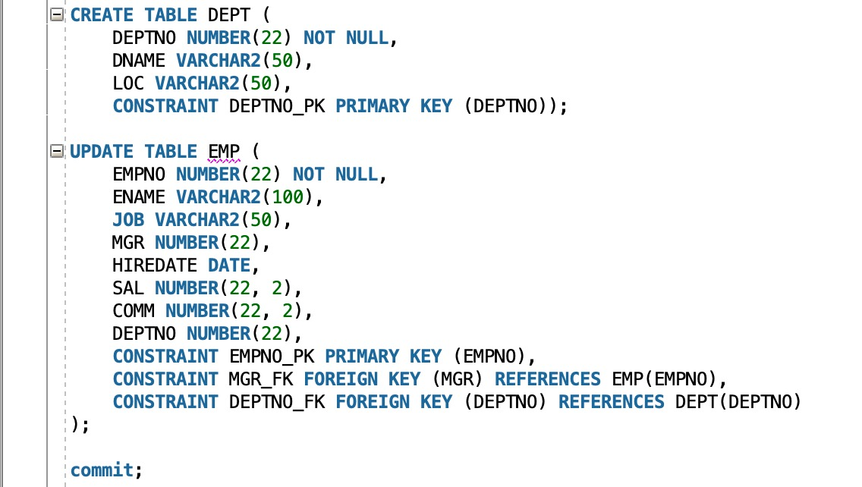  
  
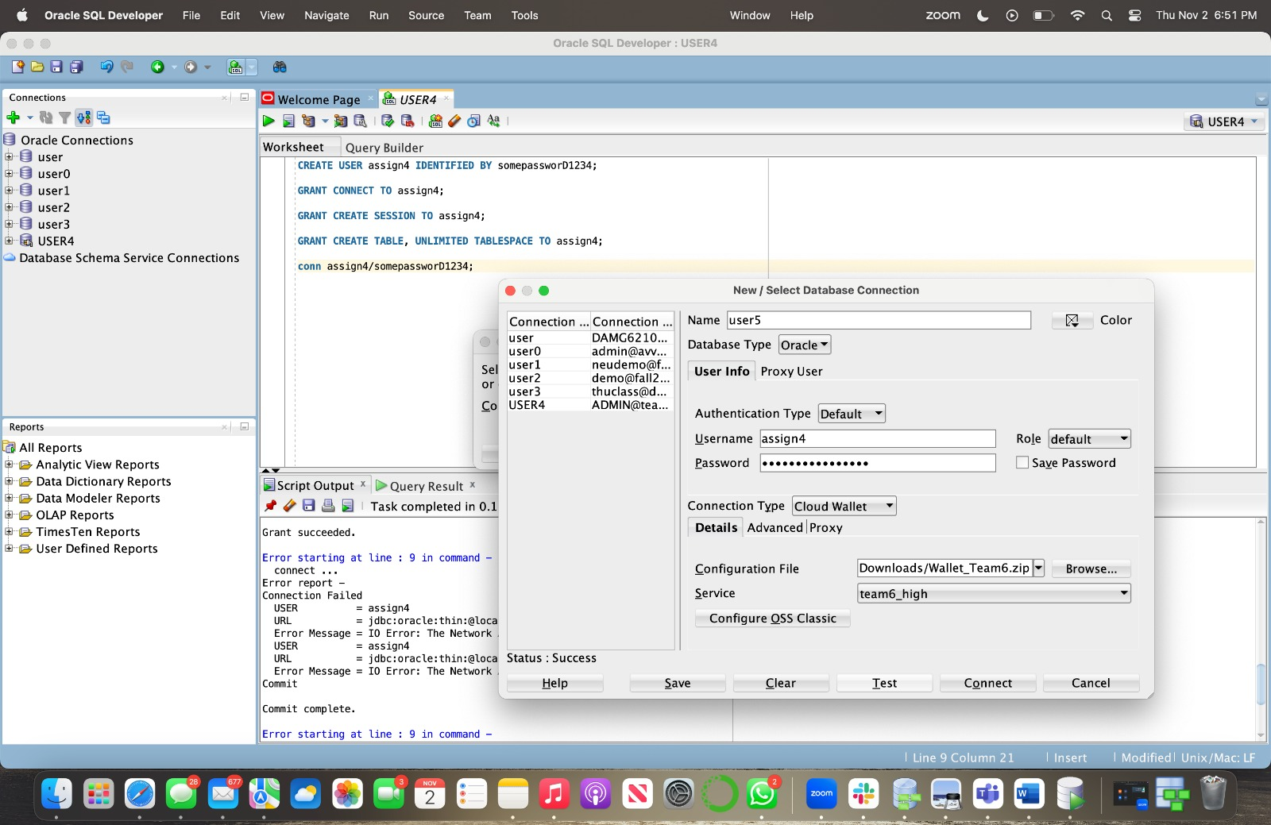

**(B)** Insert below records into DEPT table   
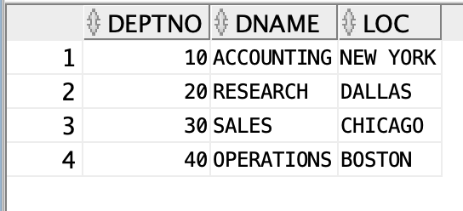

**(C)** Insert below records into **EMP** table (Empty column means you need to insert NULL value)

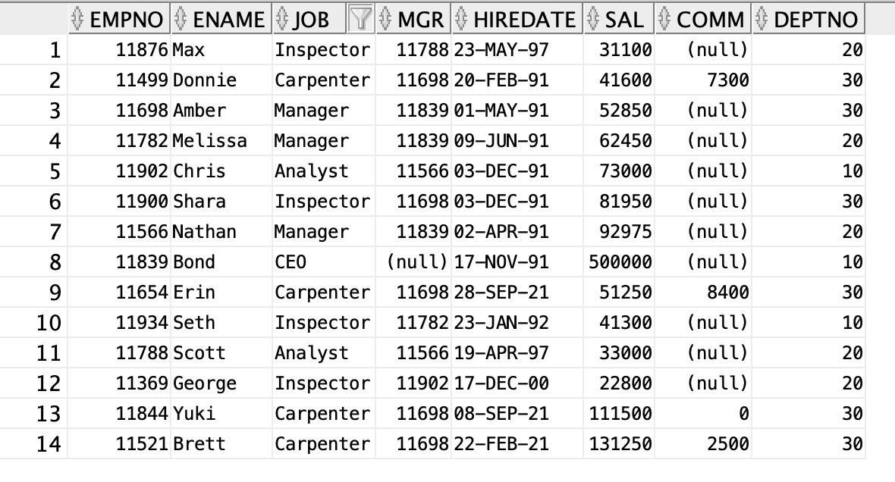

**Question #2**

**(A) I**n your database to create bricks table and also it adds some rows   
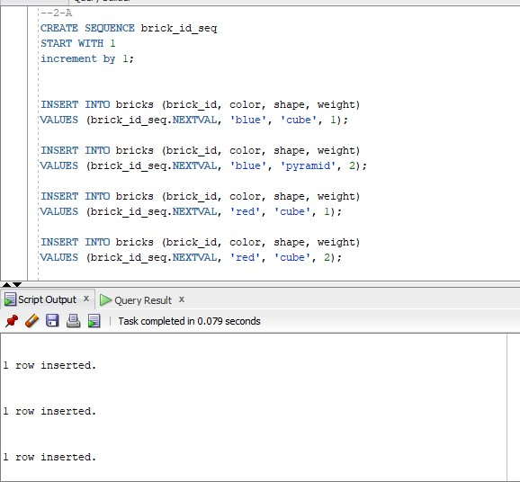  
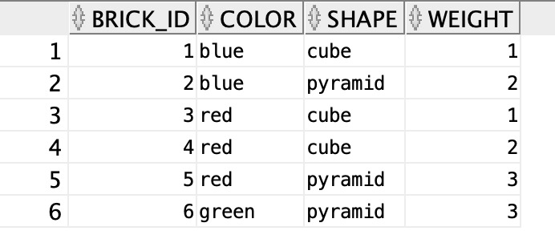

**(B)** Write a query to display below output **-- Note** BRICK_ID's are for reference purpose only. These values will be based on your sequence values that you used during the insert

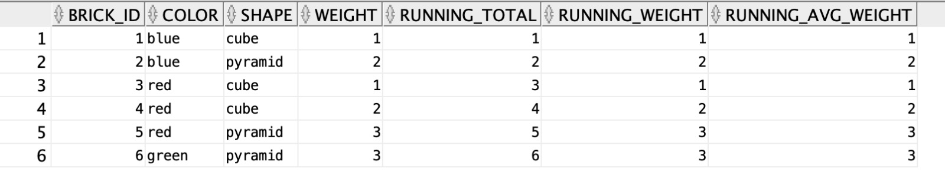

**(C)** Write a query to display below output  
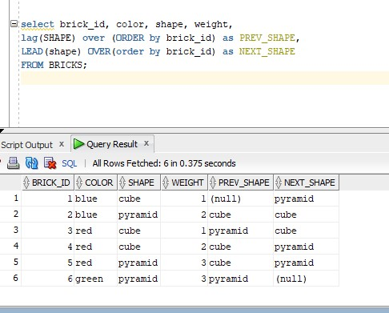

**Question #3**

**(A)** Run below script  
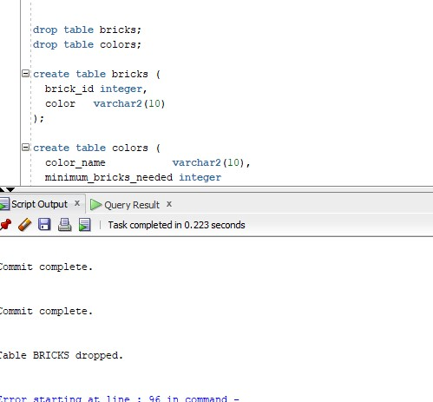

**(B)** Write a query to return below output **-** You need to show the minimum brick id for each color. and for colors that doesnt have Bricks should show as null value (In below output "-" means null)

SCRIPT:

select v.color_name, min(x.brick_id) from colors v

join bricks x on v.color_name = x.color

group by v.color_name;  
  
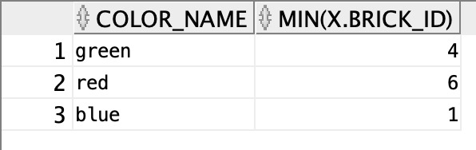

**(C)** Write a query to return below output   
SCRIPT:

WITH ColorCounts AS (

SELECT color, COUNT(*) as count

FROM bricks

GROUP BY color

),

AverageCount AS (

SELECT AVG(count) as avg_count

FROM ColorCounts

)

SELECT cc.color, cc.count

FROM ColorCounts cc, AverageCount ac

WHERE cc.count < ac.avg_count;  
  
